**Recommend top 10 movies to a user (called the "input user") using user-based collaborative filtering with Pearson correlation.**

**Load movie data**

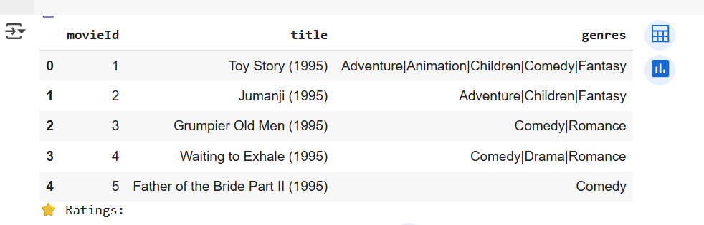

**So each movie has a unique ID, a title with its release year along with it (Which may contain unicode characters) and several different genres in the same field. Let's remove the year from the title column and place it into its own one by using the handy extract function that Pandas has.**

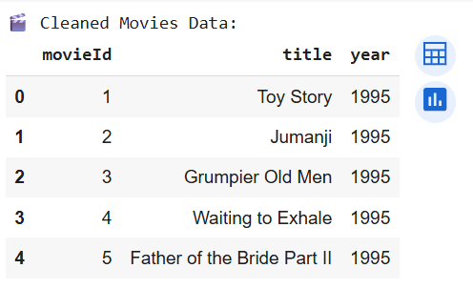

**Every row in the ratings dataframe has a user id associated with at least one movie, a rating and a timestamp showing when they reviewed it. We won't be needing the timestamp column, so let's drop it to save on memory.**

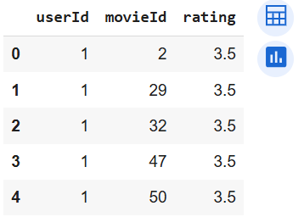

**Create new user**

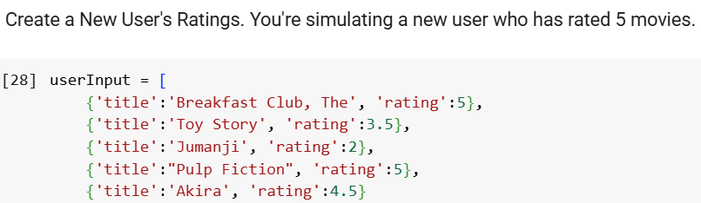

**Match These Movies with movies_df to Get Their movieId. This merges the movie titles with their movieIds, which are needed to find similar users.**

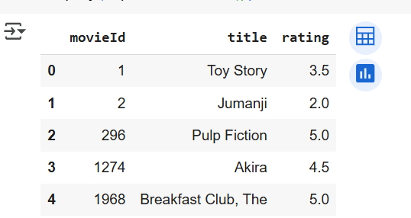

**Find All Users Who Have Watched These Movies. This groups users who have watched at least one of the same movies as the input user.**

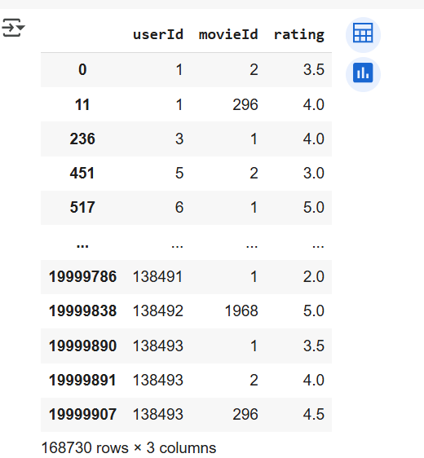

**Top 10 recommendations**

